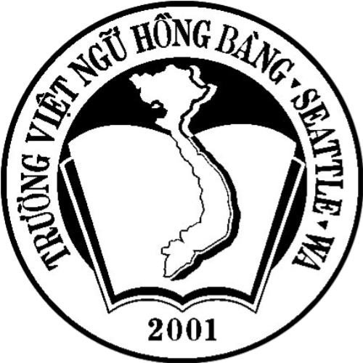 | STUDENT REGISTRATION FORM  HONG BANG VIETNAMESE LANGUAGE SCHOOL  A Non-Profit Organization in King County, Washington.  www.hongbangschool.com

VN-Grade:_____________

Room:_____________
Teachers:___________________________________________

Student’s Name (Last, Middle, First) ______________________________________________________________________
Date of Birth ____________________ Age _______ Email ____________________________________________________
Address ______________________________________________________City_________________ Zip _______________

Father’s Name (L, M, F) ___________________________________ Cell Phone (_________)________________________

Mother’s Name (L, M, F) __________________________________ Home Phone (________)______________________

MEDICAL INFORMATION AND LIABILITY WAIVER:
We, the parent(s)/guardian(s) of the above listed student understand that the school will exercise caution to protect the students during school hours. However, we recognize that in case of accident/injury to our child; the cost of treatment is our responsibility and not the responsibility of the HBVLS and/or the school from which HBVLS borrows to conduct its program. We authorize Hong-Bang Vietnamese Language School to release information on this sheet for medical care.

Emergency Contact Phone __________________________________Relationship to Child ________________________
Medical Information (Allergies – food, medications, etc.): __________ __________________________________________
___________________________________________________________________________________________________
Hospital you would like your child taken in case of an emergency: _________________ __________________________
Family Doctor’s Name ________________________________________________ Phone (_________)_________________

PARENT OR GUARDIAN APPROVAL:
____________________________________________ Date ____________________________

